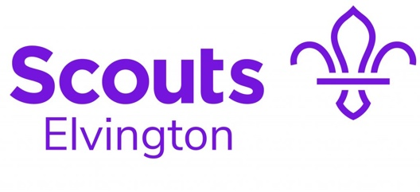

Policy on The Use and Carrying of Knives

Approved by Executive Committee Date

Contents
Policy on The Use and Carrying of Knives 1
Version Control 1
Introduction 2
The Group Policy on Knives 2
The law 2
Rules 2
Links from The Scout Association: 3

Version Control

Version | Author/ Editor | Release Date
1.0 | Alison Stead

Introduction
A knife is a valuable tool to have when on a camp, expedition and for certain activities. There are many different types and sizes of knife. As with all tools the right type of knife should be used for the job or work being undertaken. In addition to safety there are also legal considerations when carrying a knife which must be understood and followed.
For the purposes of this policy Beaver Scouts, Cub Scouts, Scouts and Explorer Scouts will be referred to simply as Scouts. Beavers and Cubs are most likely to come into contact with kitchen knives, ranging from cutlery to small paring knives and larger utility knives. Scouts and Explorers may encounter Swiss Army (folding) penknives, sheath knives, locking and clasp knives and multi tools. In all cases it is important that, before using any knife, the individual is taught how to use it safely, the rules concerning when and where it can be carried and the kind of jobs the various types of knife should be used for.
Elvington Scout Group’s Policy on Knives
As with all activities, we are governed by the Scout Association’s Policy Organisation and Rules, which
can be found on their Website, the following summarised key points from this policy:

The law
The Criminal Justice Act 1988 describes what is considered to be an offensive weapon and Section 139 details what knives are banned and what knives can be carried and in what circumstances:
- In general it is an offence to carry a knife in a public place without a good reason, this may include Scout camp sites and activity centres
- It is illegal to use any knife in a threatening way
- It is not illegal to carry a folding knife (non-locking blade) in public provided the length of the cutting edge of the blade does not exceed three inches (7.62cm)

Rules
- The law, as summarised above, will be followed by all members of the Group.
- Scouts should not bring a knife to an activity or camp unless specifically requested to do so, if knives are needed for an activity they will normally be provided by the Group.
- Knives will be transported securely to and from activities by an adult.
- No Scout will carry a knife without the specific permission of a leader present at the activity.
- No Scout will carry a knife with the blade exposed (the blade should always be folded away or sheathed).
- Knives will only be carried when the activity dictates that they are likely to be needed.
- Scouts will be trained in the use of a knife before using one. Training in the use of one type of knife does not mean the Scout is trained in the use of all knives.
- While using a knife Scouts will be supervised by an adult at all times.
- When not in use knives should be put away and secured in the possession of an adult.
- Knives will not be stored in Scout’s tents.
- Where possible knives will be stored in a location that can be locked (e.g. boot of an adults car, store room, site office, etc.)

Further information on the Scout Association website:

https://www.scouts.org.uk/volunteers/staying-safe-and-safeguarding/safety/keeping-safe-at-camp/scout-knife-safety-guidance/

